ARCHITECT REVIEW
SCC-3380 | Incident-Case Relationships
Great Plains Merge to UAT | Read-only retrieval and check-only readiness assessment
Source | GreatPlainsMerge (Sandbox) | Org 00DEa00000GkAsHMAV
Target | GreatPlainsUAT (Sandbox) | Org 00DEa00000FZlLBMA1
Review date | 26 August 2026
Retrieval | Succeeded with 3 missing story items | Job 09SEa00000icZA2MAM
Check-only | Failed | Job 0AfEa00000bbQnpKAE | 2/15 passed
Decision | NO-GO - Changes Requested before promotion
Boundary | No records, deployment, activation, or org metadata were changed

ARCHITECT DECISION
Do not promote SCC-3380. The five source flows are active, but three required guardrails are absent, the NOC permission set is unassigned, and the UAT dry run failed 13 of 15 components.

Acceptance outcome
# | Scope | Result | Evidence
1 | Incident/Case linking | Partial pass | Case Related Issue layouts and active stamp/clear flows exist in source; UAT lacks Related_Outage__c and other prerequisites.
2 | Type and circular controls | Fail | Only the non-Trouble Ticket Incident-link check exists. The three listed validation rules for parent/type/circular protection are absent.
3 | Incident field sync | Partial pass | Active Incident flow maps standard and custom Priority. Runtime was not executed; UAT validation fails on missing Incident and Case fields.
4 | Confirmed bulk close | Partial pass | Source logic requires Closed transition plus checkbox. Runtime was not executed and target validation failed.
5 | Parent close and unlink | Partial fail | Parent close and unlink logic exist, but child updates are not constrained to Trouble Ticket record type and parent guardrails are absent.
6 | Reporting | Fail in UAT | Source report type exists; UAT has no Trouble_Tickets__r relationship, so the report type cannot validate.

Solution and control path
The intended relationship model is visible in source, but access, guardrails, and target prerequisites break the end-to-end promotion path.
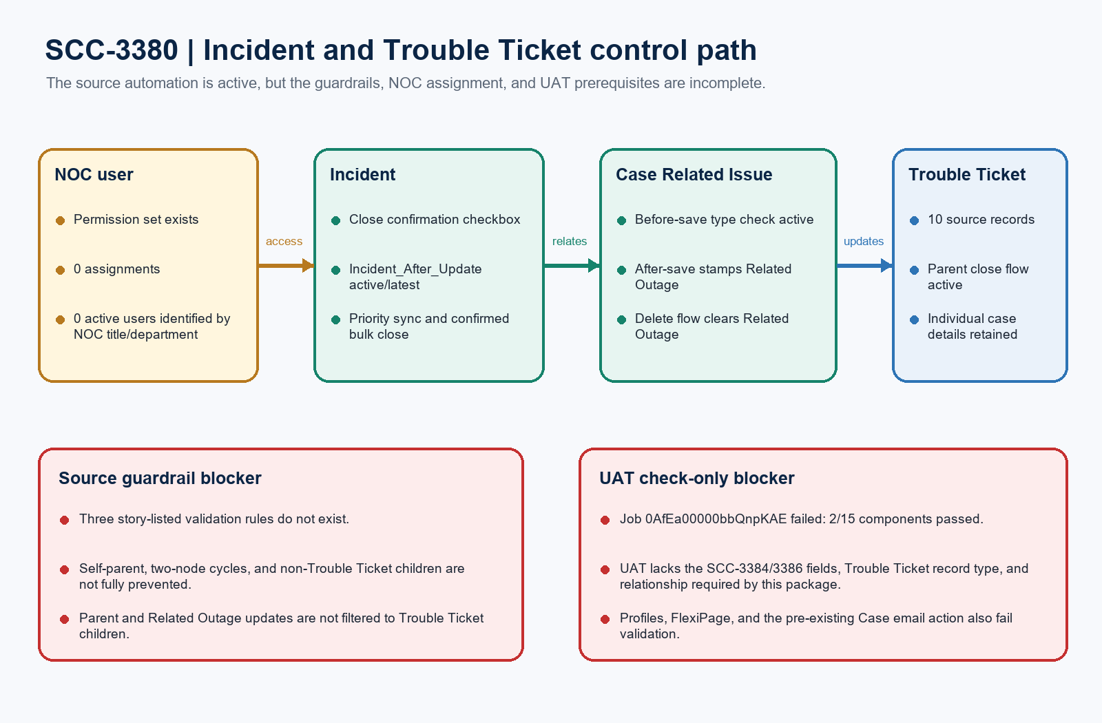
Figure 1. SCC-3380 Incident and Trouble Ticket control path
DESIGN READING
Green/blue is configured in source. Amber needs ownership. Red blocks approval.

Detailed source findings

1. Automation and controls
Automation | State | Architect evidence
SCC_3380_Case_Related_Issue_Before_Save | Active/latest | Blocks a non-Trouble Ticket Case from being linked to an Incident.
SCC_3380_Case_Related_Issue_After_Save | Active/latest | On create, stamps Case.Related_Outage__c for an Incident link.
SCC_3380_Case_Related_Issue_After_Delete | Active/latest | Before delete, clears Related Outage only when it matches the removed Incident.
Incident_After_Update | Active/latest | Syncs Priority and performs checkbox-confirmed bulk close through both relationship paths.
Case_After_Trigger_Flow | Active/latest | Closes open child Cases when a Trouble Ticket parent closes; also retains the existing email action.

2. Missing guardrails
Control | State | Risk
Case.SCC_3380_Prevent_Circular_Parent_Case | Absent | No SCC-3380 rule exists to block self-parenting or A-to-B-to-A cycles.
Case.SCC_3380_Child_Must_Be_Trouble_Ticket | Absent | A non-Trouble Ticket can remain a child; the parent-close flow updates all open children.
CaseRelatedIssue.SCC_3380_Case_Must_Be_Trouble_Ticket | Absent | The before-save Flow provides a narrower Incident-link control, not the listed validation rule.
Record-type filters | Incomplete | Incident Related Outage updates and parent-child closure do not filter target Cases by Trouble Ticket record type.

GUARDRAIL BLOCKER
The story's circular and child-type acceptance criteria are not satisfied by the retrieved source package.

Check-only deployment evidence

GreatPlainsUAT validation
Metric | Result | Evidence
Job | 0AfEa00000bbQnpKAE | checkOnly=true; rollbackOnError=true; NoTestRun
Package | 15 components / 23 files | 2 component successes; 13 component failures
Passed | 2 | Incident.Close_Related_Trouble_Tickets__c and SCC_3380_Case_Related_Issue_Before_Save
Tests | 0 | No Apex in scope; no runtime story tests were executed

Failure group | Count | Exact blocker
Missing SCC prerequisites | 7 | Report type; Case-Trouble Ticket; Case-Case Layout; Incident_After_Update; After Save; After Delete; plus permission-set dependency on Related_Outage__c.
Incident layout | 1 | Outage Incident Layout references missing Incident.Affected_Area_Region__c.
Profiles | 3 | Admin/API profiles use unknown ArchiveArticles permission; Standard references missing Case.Trouble_Ticket record type.
Lightning page | 1 | Incident_Record_Page1 has an unsupported shouldDisplayFiltersOnRight property.
Existing Case flow | 1 | Case_After_Trigger_Flow emailTemplateName input type does not match the assigned value in UAT validation.
Story omissions | 3 not packaged | All three listed SCC-3380 validation rules are missing in the source org.

Read-only runtime evidence
Evidence | Count | Interpretation
Trouble Ticket Cases | 10 | Source org aggregate only; no records changed.
Case Related Issues | 1 | The observed relationship type is Incident.
Cases with Related Outage | 1 | Shows the source relationship is in use, but does not prove all acceptance paths.
Permission-set assignments | 0 | SCC_3380_NOC_Incident_Case_Relationship is not assigned.
Identified active NOC users | 0 | No active user matched NOC in Title or Department.

Required approval gates
Gate | Required action | Owner | Evidence needed
1 | Implement the three guardrails | Admin / Architect | Deploy active controls for self/circular parent chains, Trouble Ticket-only children, and Trouble Ticket-only Incident links.
2 | Sequence prerequisite stories | Release manager | Move SCC-3384/3386 record type, Related Outage, Service Address, Priority, Incident fields, and relationship metadata before SCC-3380.
3 | Constrain update scope | Flow owner / Architect | Filter all bulk updates to Trouble Ticket Cases and decide whether Case Related Issue edits must resync Related Outage.
4 | Repair deploy artifacts | Salesforce admin | Replace broad profiles with focused access, remove unsupported FlexiPage drift, and fix the Case email-action input type.
5 | Identify the NOC persona | Product owner / Security | Provide the named NOC user/profile and assign the focused permission set; prove field, tab, layout, and report access.
6 | Revalidate and execute UAT | QA / Release manager | Require a clean check-only result, then execute the five story tests with IDs/screenshots before any promotion approval.

Ready-to-paste architect response
STORY COMMENT
Architect review completed for SCC-3380 using GreatPlainsMerge as source and GreatPlainsUAT as the check-only target. Changes Requested / NO-GO: all five retrieved flows are active/latest in source, but the three story-listed validation rules are absent, so circular parent relationships and Trouble Ticket-only child enforcement are not fully implemented. The NOC permission set has zero assignments and no active NOC persona was identified. Check-only job 0AfEa00000bbQnpKAE failed with 13 of 15 components; only the Incident confirmation checkbox and the before-save Case Related Issue flow passed. The failures include missing SCC-3384/3386 fields and record type, profile drift, an unsupported Incident page property, and the existing Case email-action input mismatch. Complete the six gates above and require a clean validation plus the five named UAT tests before promotion. No records, metadata, activation, or deployment changes were made.

